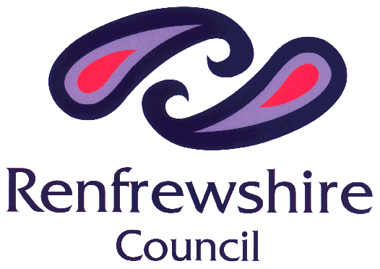
Household Waste Recycling Centre
Daily Permit for Access by Commercial Type Vehicle

Instructions:

- Complete form below;
- Save a copy for your records; and
- Email completed form to waste@renfrewshire.gov.uk by 4.30pm the day before your visit.

RESIDENT DETAILS

Name | Click or tap here to enter text.
Address | Click or tap here to enter text.
Post Code | Click or tap here to enter text.
Telephone | Click or tap here to enter text.
Date of visit | Click or tap to enter a date.
Vehicle registration | Click or tap here to enter text.
Vehicle type  (Drop down menu) | Choose an item.
Recycling centre (Drop down menu) | Choose an item.
How many visits on your chosen day? | Choose an item.

TYPE OF WASTE

Please select below the types of waste you brought to the Recycling Centre today:

ITEMS

Bathroom furniture | ☐ | Cardboard | ☐ | Furniture | ☐ | Mattresses | ☐ | Soil | ☐
Batteries | ☐ | Chipboard | ☐ | Garden waste | ☐ | Metal scrap | ☐ | Textiles | ☐
Books | ☐ | Construction waste | ☐ | Gas cylinders | ☐ | Motor oil | ☐ | White goods | ☐
Brick / Rubble | ☐ | Electrical appliances | ☐ | Glass | ☐ | Paper | ☐ | Wood | ☐
Cans | ☐ | Fridge / Freezers | ☐ | Kitchen furniture | ☐ | Plastics | ☐ | Other- state below | ☐
OTHER ITEMS: Click or tap here to enter text.

What is the activity you are undertaking to produce this waste?

ACTIVITY: Click or tap here to enter text.

TO BE COMPLETED BY HWRC ATTENDANT/ENFORCEMENT OFFICER

The following has been checked by HWRC Attendant/Enforcement Officer:

 | Yes | No
Identification | ☐ | ☐
Residency documents | ☐ | ☐
Waste | ☐ | ☐
HWRC Attendant/Enforcement Officer
Date

Terms and Conditions

- Renfrewshire Household Waste Recycling Centres are for use only by residents of Renfrewshire who wish to deposit waste materials from their own property.
- It is illegal to deposit trade or commercial waste at the Renfrewshire Household Waste Recycling Centres.
- The permit system applies to all Type B vehicles including hire vehicles and commercial vehicles on loan from a place of work.
- Permits are not transferable.
- Permits are valid for the date indicted on the permit ONLY
- Permits are valid for the vehicle indicted on the permit ONLY
- All waste brought to Renfrewshire Household Waste Recycling Centres will potentially be subject to a visual inspection by the Site Attendants and Enforcement officer
- The Site Attendants reserve the right to refuse access to the site if it is suspected that the waste is commercial in origin (booking does not give automatic right to tip).
- Residents are asked to pay attention to all signage on site with regards to health and safety of residents and staff.
- Residents are asked to follow the advice of the Site Attendants and site signage in order to use the facilities on site.
- Any abuse, bullying or violent behaviour towards any of our site staff will not be tolerated.
- CCTV is in operation at the site. Information collected will be used for monitoring access to the site, and it may be shared with other organisations for the purpose of investigating breaches of waste regulations and the prevention and detection of crime.
- Renfrewshire Council reserve the right to undertake investigations regarding the origin of any wastes presented and to restrict access to its site if false or inaccurate information is provided.
- Renfrewshire Council reserves the right to refuse or cancel the permit if provided with false or misleading information.

DECLARATION BY USER

It is illegal to deposit waste produced from any form of commercial activity at Renfrewshire Household Waste Recycling Centres. The Site Attendant is under strict instructions to refuse such wastes and also refuse any wastes brought in by any commercial type of vehicle, unless a Declaration has been completed.

If you wish to state that the waste you are presenting today is not of a commercial nature, you must complete the Declaration and provide the required details above immediately before you can proceed to deposit any waste at a Centre. Upon receipt of the information, we may investigate to verify your Declaration. This may involve contact from an Enforcement Officer to verify the source and nature of the waste involved.

Where our investigation reveals that the waste you have deposited was of a commercial nature, we will provide your details to the appropriate governing bodies to proceed legal action under the Environmental Protection Act (1990) – Duty of Care. Fixed Penalty Notices of £200 may be issued and when referred to the court penalties can be up to £40,000.

Declaration

I hereby certify that the waste materials deposited by me today are from a private dwelling within Renfrewshire, and were not produced from any trade, business or commercial activity. I have read and accepted the above terms and conditions.

Signed  (Type name if completing online) | Click or tap here to enter text.
Date | Click or tap to enter a date.

